User Guide — The AI Visionary

The AI Visionary — User Guide

Overview
The AI Visionary is a knowledge support tool designed to provide insights into Techcombank’s AI strategy, vision, and roadmap across various divisions. All information presented is sourced from official Techcombank documents, ensuring accuracy and reliability.
──────────────────────────────────────────────────

Interface Layout
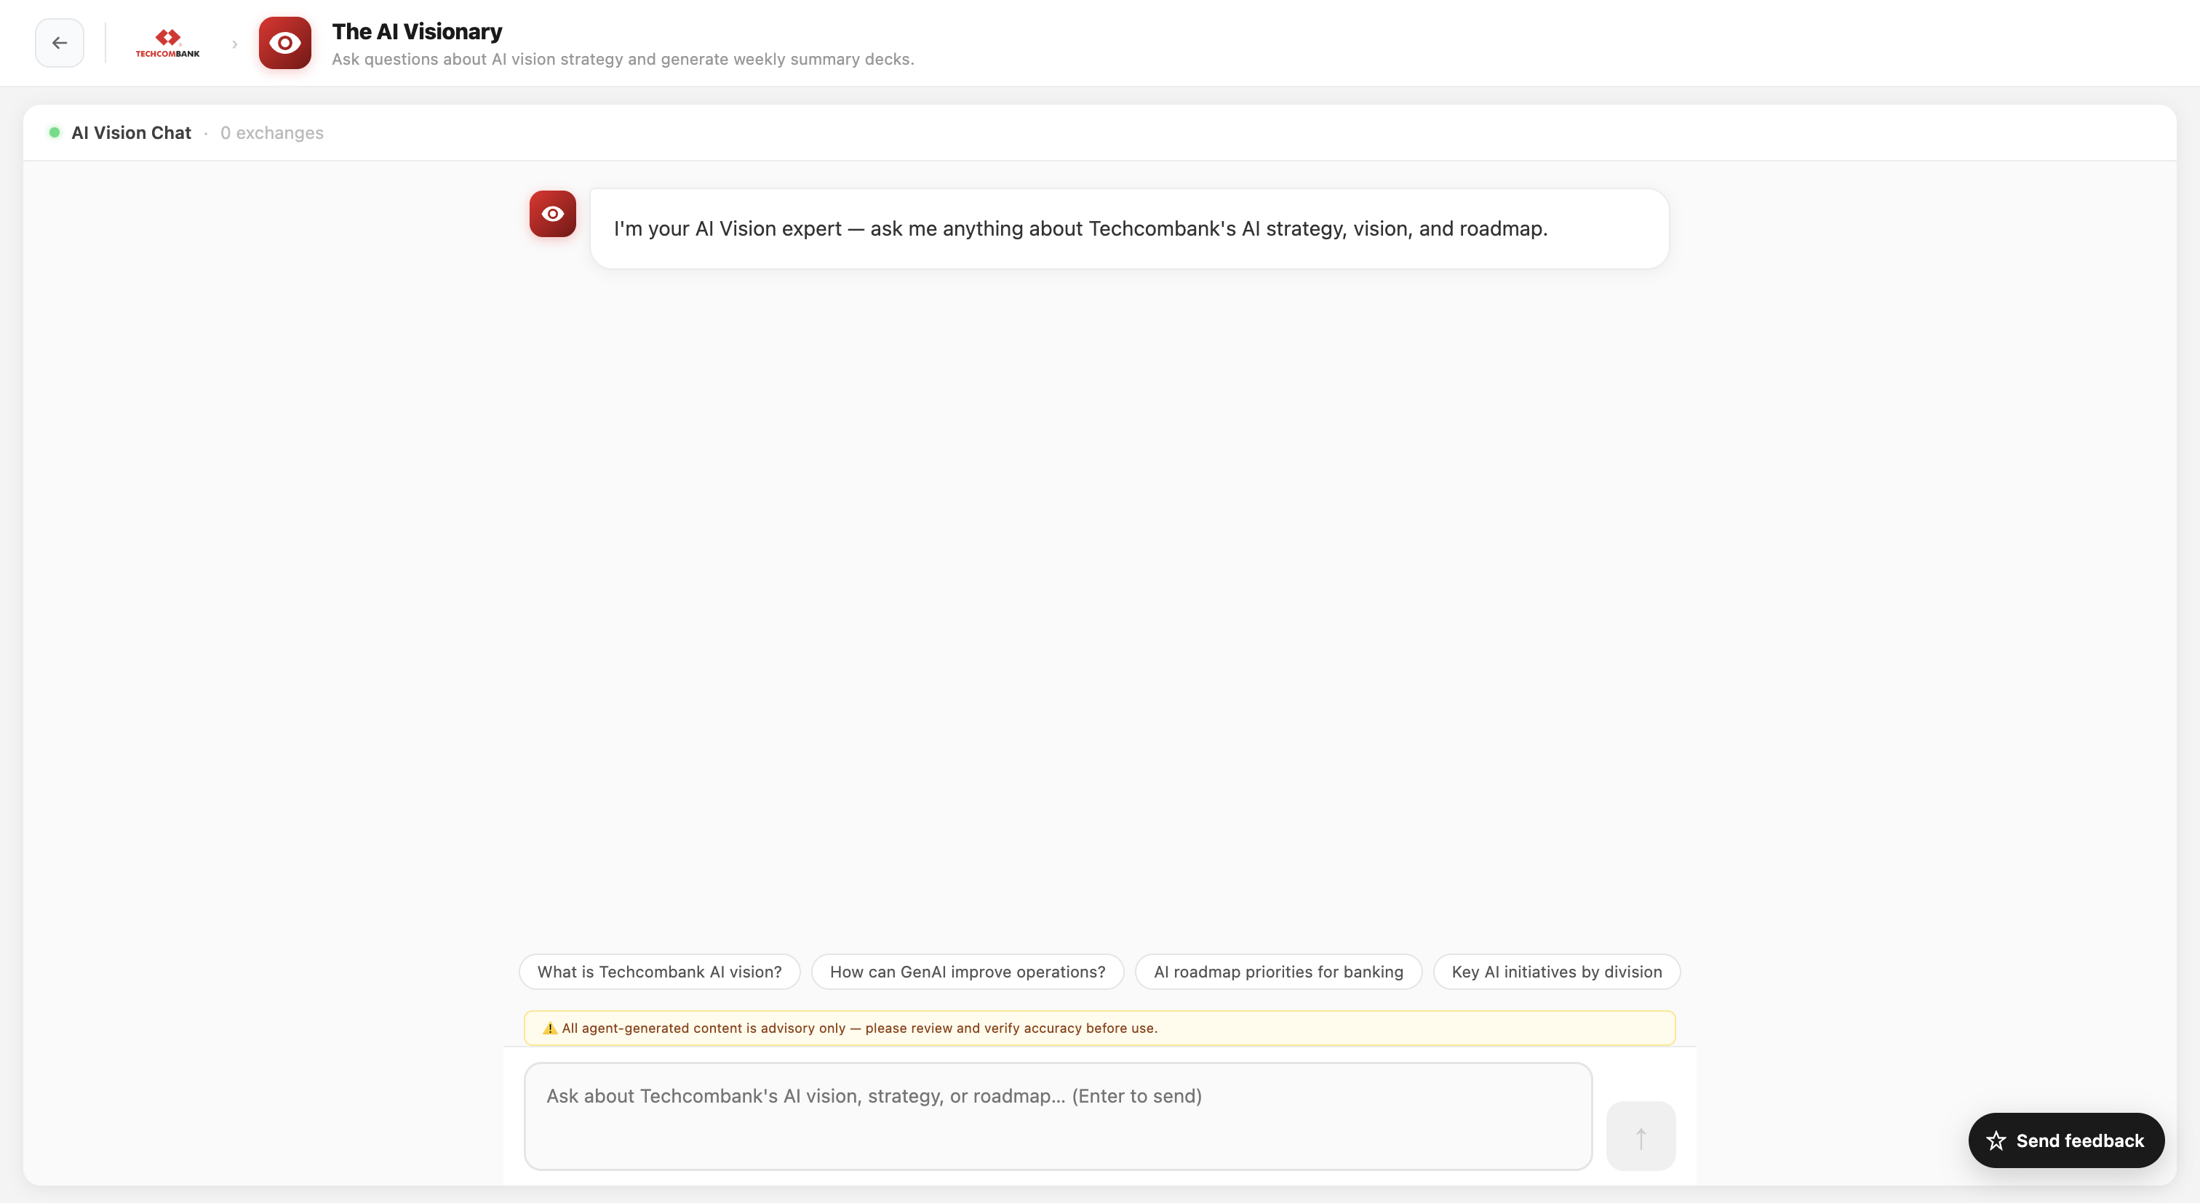
Area | Purpose
Main area | Main area is chat-based conversation, where users can interact with the AI to ask questions about Techcombank’s internal information
──────────────────────────────────────────────────

How to Use

AI Vision Q&A
Simply type your question about AI strategy, vision, or technology trends. The AI responds with detailed, informed answers.
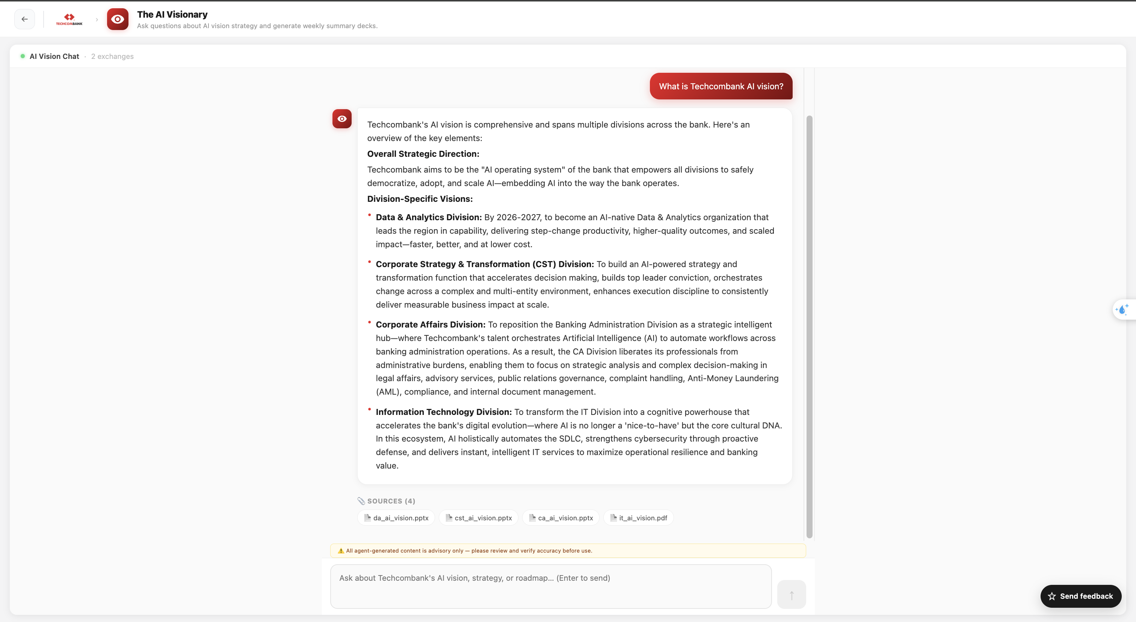
Example questions (hint chips):
- "What is Techcombank AI vision?"
- "How can GenAI improve operations?"
- "AI roadmap priorities for banking"
Press Enter to send. The AI responds with markdown-formatted answers.

How the AI Works
The AI analyzes all available internal data sources provided to it and identifies relevant information related to the user’s query. Based on this analysis, it generates a comprehensive answer.
At the end of each response, the AI includes a list of sources it referenced, enabling users to track and validate the information.
User can download the resource by press on them.

AI Vision Feedback
Users can provide feedback via the feedback button located at the bottom right corner. This includes sharing opinions, suggestions, or reporting issues.
Collecting more feedback enables deeper insights, helping continuously improve and enhance TÀI Studio.
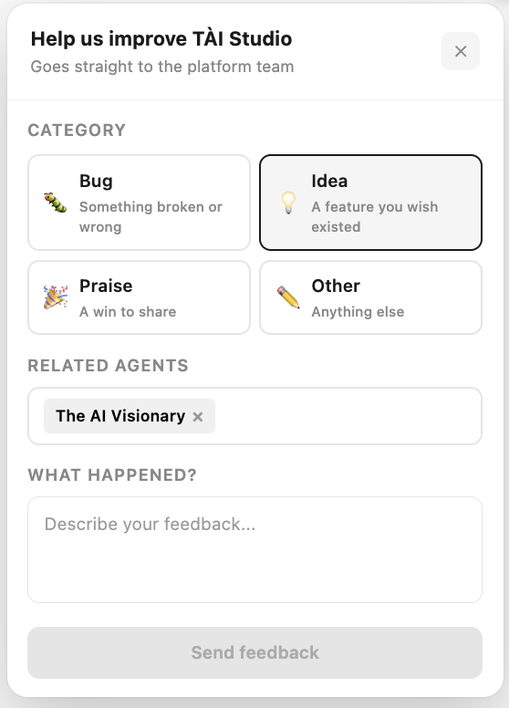
──────────────────────────────────────────────────

Tips
- Ask clear, specific questions to get better answers
- Use example questions (hint chips) as a quick starting point
- Check the listed sources for more details and validation
- Works well for weekly summary decks, strategy presentations, and AI roadmap updates
──────────────────────────────────────────────────

Limitations
- Presentations use text only — no embedded images
- Quality depends on the specificity of your request
- The AI's knowledge is focused on AI/technology strategy topics
- Answers depend on available internal documents only
──────────────────────────────────────────────────
Last updated: 2026-06-22

